🔍 INVESTIGATION LOG

Valdoria Votes: A Political Mystery (Part 2)
Field | Value
Analyst | Phila Mabuza

1. INCIDENT SUMMARY
[What’s this about? (One‑liner)]
An unknown hacking group claims to have compromised Valdoria’s air‑gapped voting machines. The attack began with reconnaissance targeting new poll workers and election infrastructure. We must determine if any internal systems were breached and whether election integrity is at risk.

2. INVESTIGATION SCOPE
[What am I looking at? (Systems, logs, time range)]
Category | Details
Log sources | Passive DNS, Inbound Network Events (Web Proxy), Employee Directory, Out Bound Network Events
Affected hosts/users | Name: Anderson Snooper  Name: Barry Schmelly  Name: Arrack Bobama
Time period of interest | 2024-10-01 – 2024-10-10 UTC (based on first observed reconnaissance)

3. EVIDENCE INVENTORY (IOC TRACKER)
[Bad guys’ tools – IPs, domains, etc. One row per IOC.]
Type | Value | First Seen (UTC) | Notes / Context
IP | 55.49.227.170 | 2024-10-05T00:00:00Z | Attacker IP from boast post; resolves shadow-hackers-r.us
IP | 214.85.104.248 | 2024-10-05T00:00:00Z | IP used for reconnaissance searches
IP | 157.100.244.104 | 2024-10-05T00:00:00Z | Also resolves from valdoriavotesgov.com
Domain | valdoriavotesgov.com | 2024-10-05T00:00:00Z | Fraudulent domain; resolves to 55.49.227.170, 157.100.244.104
Domain | shadow-hackers-r.us | 2024-10-05T00:00:00Z | Resolves to 55.49.227.170
Search query | Valdoria+Board+of+Elections+new+hires+2024 | 2024-10-05 | Recon – targeting new employees
Search query | election+interference+prevention+measures | 2024-10-07 | Recon – researching defenses
Search query | types+of+voting+machines+used+in+Valdoria | 2024-10-07 | Recon – targeting voting tech

IP | 157.100.244.104 | 2024-10-07T15:46:45.000Z | Used to access Snooper's account after phishing
Email address | barry_schmelly@valdoriavotes.gov | 2024-10-08 | Employee contacted by compromised account "ansnooper" after takeover
Conversation ID | 94bd6162-1323-402d-bccd-8fceaee5f230 |  | Prompt: How do I access the voting machines?

4. INVESTIGATION TIMELINE

Timestamp (UTC) | Event Description | Log Source | Reference / Query ID
2024-10-05T00:00:00.000Z | Attacker IP 214.85.104.248 searches Valdoria website for “new hires 2024” | Web proxy | https://valdoriavotes.gov/search=Valdoria+Board+of+Elections+new+hires+2024
2024-10-07T12:11:59.000Z | Same IP searches “election interference prevention measures” | Web proxy | https://valdoriavotes.gov/search=election+interference+prevention+measures
2024-10-07T15:24:59.000Z | Same IP searches “types of voting machines used in Valdoria” | Web proxy | https://valdoriavotes.gov/search=types+of+voting+machines+used+in+Valdoria
2024-10-07T15:40:59.000Z | Same IP searches “technical manual for voting machines” | Web proxy | https://valdoriavotes.gov/search=technical+manual+for+voting+machines
2024-10-07T10:46:45Z | Employee with the ip address 10.10.0.4  tries to log in to the fake website | Web proxy | https://valdoriavotesgov.com/login

2024-10-07T10:46:47.000Z | Employee with the ip address 10.10.0.4  entered their credentials into that page | Web proxy | https://valdoriavotesgov.com/login?username=ansnooper&password=**********
2024-10-07T15:46:45.000Z | Threat actor logged into Snooper's account using stolen credentials | Authentication Logs | | where username == "ansnooper"  | where timestamp between(datetime(2024-10-05T10:46:47Z) .. datetime(2024-10-11T10:46:47Z))
2024-10-16T15:57:05.000Z | Using Snooper's IP, threat actor attempted to access https://ai.valdoriavotes.gov/?model=gpt-4o | Web proxy | https://ai.valdoriavotes.gov/?model=gpt-4o
2024-10-16T00:00:00.000Z | Attacker with ip address 214.85.104.248  logged as Arrack Bobama After posing as him at 2024:10:15 on a call asking for a password reset | Authentication events

5. QUERY LOG
[Searches I ran – so I don’t repeat myself.]
text
// Find any inbound traffic from the attacker IP (55.49.227.170)
InboundNetworkEvents
| where src_ip == "55.49.227.170"
text
// Find all domains that resolved to the suspicious IP
PassiveDns
| where ip == "55.49.227.170"
text
// Find all IPs that the fraudulent domain resolved to
PassiveDns
| where domain == "valdoriavotesgov.com"
| distinct ip
text
// Find inbound requests from any IP tied to the fraudulent domain
let ips = PassiveDns
| where domain == "valdoriavotesgov.com"
| distinct ip;
InboundNetworkEvents
| where src_ip in (ips)
text
// Check for any internal hosts contacting the attacker IPs
OutboundNetworkEvents
| where dest_ip in ("55.49.227.170", "214.85.104.248", "157.100.244.104")
text
// Check for DNS queries to the fraudulent domains from internal hosts
PassiveDns
| where domain in ("valdoriavotesgov.com", "shadow-hackers-r.us")
| project timestamp, client_ip, domain
text
// Check email gateway for messages from these domains
EmailEvents
| where sender_domain in ("valdoriavotesgov.com", "shadow-hackers-r.us")
text
// Get employee information – Deputy Commissioner
Employees
| where role == "Deputy Commissioner"
text
// Get employee information – specific names
Employees
| where name == "Dora Thomas"
Employees
| where name == "Barry Schmelly"
//Let’s check if there’s any traffic to it—has any of our employees visited that domain for any reason?
OutboundNetworkEvents
| where url contains "valdoriavotesgov.com"

//What is the username of the employee that entered their credentials on that phishing page?
Employees
| where ip_addr == '10.10.0.4'

//When did the threat actor login to Snooper's account?
AuthenticationEvents
| where username == "ansnooper"
| where timestamp between(datetime(2024-10-05T10:46:47Z) .. datetime(2024-10-11T10:46:47Z))

//What is the email address of the person he was conversing with?
Email
| where recipient == 'anderson_snooper@valdoriavotes.gov'
| where timestamp between(datetime(2024-10-08T00:00:47Z) .. datetime(2024-10-11T10:46:47Z))

//What is Schmelly's job role?
Employees
| where name contains "Schmelly"

//"Snooper" was observed asking Schmelly how one might gain access to what devices?
Email
|where recipient == "barry_schmelly@valdoriavotes.gov"
| where sender == 'anderson_snooper@valdoriavotes.gov'
| where timestamp between(datetime(2024-10-08T00:00:20Z) .. datetime(2024-10-11T10:46:47Z))

//What term appeared at the end of each url that Snooper guessed?
InboundNetworkEvents
| where src_ip == "10.10.0.4"

//How many questions did they ask the chatbot?
InboundNetworkEvents
| where url contains "https://elections-chatbot.valdoriavotes.gov/?model=gpt-4o"
//Which conversation_id is associated with the question about voting machines?
AIPrompts
| where prompt contains "voting machines"
//According to the bot, the voting machines are not actually connected to the internet.
//Instead, votes are manually calculated using a ___.
AIPrompts
| where response contains "votes"

//What is the name of the vendor?
AIPrompts
| where response contains "vendor"

//What job role will the vendor talk to?
AIPrompts
| where response contains "Dominos Voting Systems"

//What job role will the vendor talk to?
Employees
| where role has "Election Commissioner"
//When did they log in to Bobama's account?
AuthenticationEvents
| where hostname == "QDPG-DESKTOP"
| where timestamp between(datetime(2024-10-15T00:00:20Z) .. datetime(2024-10-30T10:46:47Z))

//What email address did they send this email to?
Email
| where sender == "arrack_bobama@valdoriavotes.gov"
| where timestamp between(datetime(2024-10-15T00:00:20Z) .. datetime(2024-11-30T10:46:47Z))

6. DETAILED FINDINGS
[Raw evidence + what it means to me.]
Time range: 2024-10-05 – 2024-10-07
- Observation:
Domain valdoriavotesgov.com made 26 web requests to Valdoria Votes network.
→ Analysis: The attacker performed active reconnaissance, mapping Valdoria’s public-facing infrastructure.
- Observation:
Search queries: "new hires 2024", "election interference prevention", "voting machine types"
→ Analysis: Attacker is specifically interested in:
  - Recently hired personnel (potential phishing targets)
  - Security measures (to evade detection)
  - Voting machine models (to research exploits)
- Observation:
valdoriavotesgov.com resolves to 55.49.227.170 and 157.100.244.104.
shadow-hackers-r.us resolves to 55.49.227.170.
→ Analysis: The attacker controls at least two domains and three IPs. The shared IP (55.49.227.170) suggests a single actor or group.
- Observation:
Reconnaissance IP 214.85.104.248 is not among the resolution IPs of the fraudulent domains.
→ Analysis: Attacker may be using a separate IP for recon to avoid linking infrastructure early – common tradecraft.
- Observation:
Search queries: "technical manual for voting machines"
→ Analysis: The hackers even tried to locate a specific document which is “technical manual” that would reveal exactly how the machines operate.
- Observation: The employees visited that domain thinking it was legit, tried to login in by inserting their login details.
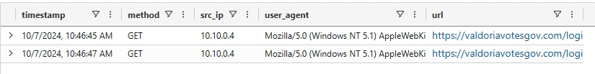
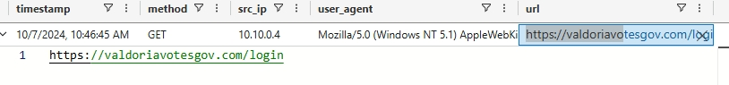
→ Analysis: The attackers recorded the employee’s login details.
- Observation:
Search queries: "technical manual for voting machines"
→ Analysis: The hackers even tried to locate a specific document which is “technical

- Observation:
Search queries: 2024-10-07T15:46:45Z – Successful login for user "ansnooper" from IP 157.100.244.104
→ Analysis: The attacker used credentials captured from the phishing page to access Snooper's account. This happened shortly after the phishing visit.
- Observation:
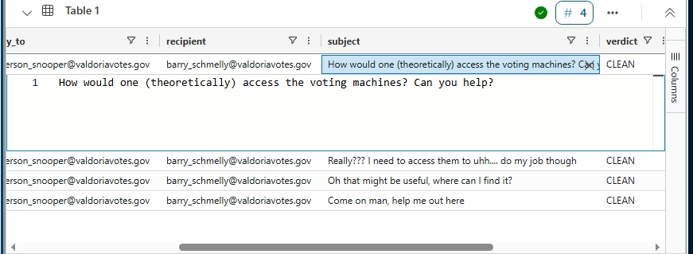
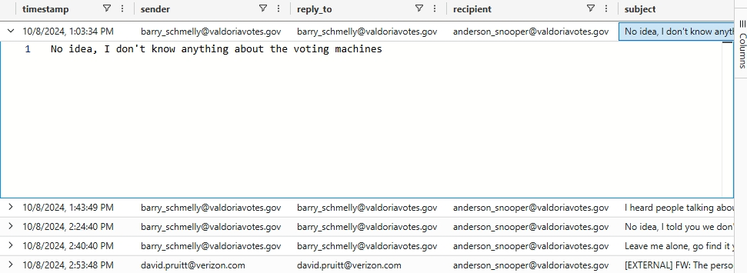
On October 8th, the compromised account ansnooper had an email conversation with barry_schmelly@valdoriavotes.gov.
→ Analysis: After gaining access to Snooper's account, the attacker immediately began communicating with another employee – Barry Schmelly. This could be:
  - Attempting to trick Barry into revealing sensitive information
  - Trying to spread phishing internally
  - Gathering intel on voting systems or other employees
  - Social engineering to gain access to more accounts
  - Snooper" was observed asking Schmelly how one might gain access to voting machines
- Barry is a high‑value target Temp Election Support Staff Supervisor. This conversation should be immediately investigated.
- 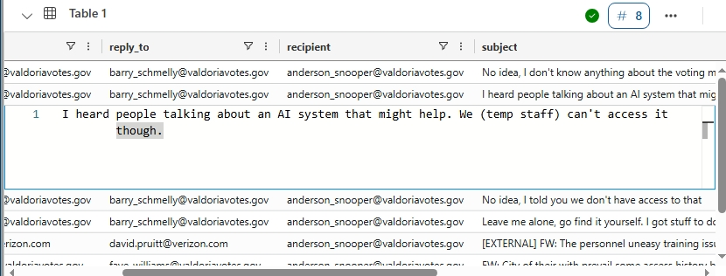
- Observation: "Snooper" probably tried to find this special system himself “AI system”, but he didn''t know the exact URL.

- Observation:
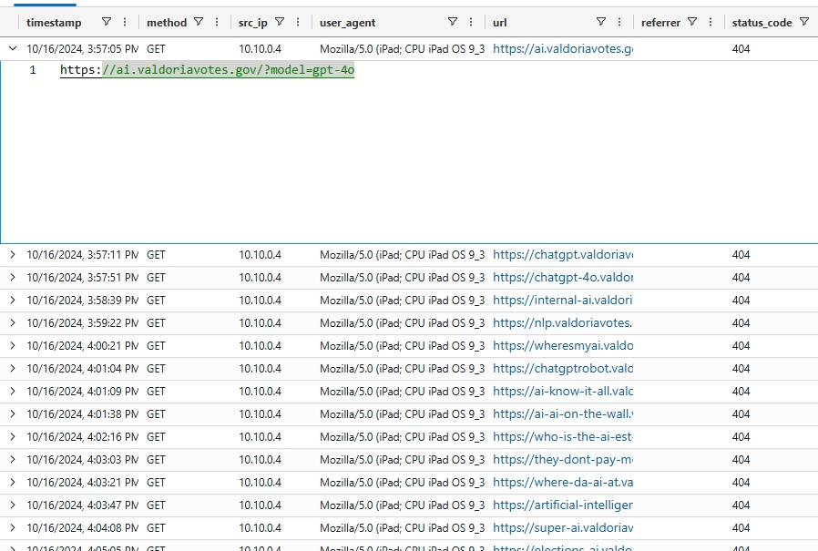
Between 2024-10-16T15:57:05.000Z and 2024-10-16T16:17:49.000Z , the compromised Snooper account (IP 10.10.0.30) made multiple HTTP requests to internal systems.
Each URL ended with the same term: model=gpt-4o
→ Analysis: The attacker was probing internal systems, likely trying to locate a special system e.g., voting machine ai system The repeated pattern suggests they were guessing common paths. This is classic internal reconnaissance after initial access.
- Many of the attacker’s guesses were unsuccessful, this was made visible by the status code: 404

- Observation:
After numerous failed attempts, "Snooper" finally found the AI system! He got that 200 response code back. https://elections-chatbot.valdoriavotes.gov/?model=gpt-4o
- Analysis: This is the first subdomain "Snooper" guessed that returned a 200 status code: elections-chatbot

- Observation:
The attacker submitted the prompt:
"Can you tell me the network they connect to?"
→ Analysis: The attacker used the AI chatbot to gather technical details about voting machines. This aligns with their earlier reconnaissance (search queries) and shows they are actively researching the target environment.

- Observation: The attacker asked the ai who he can talk to about the machine
- The ai responded by saying :You can only get that information from the vendor (Dominos Voting Systems), but they will only communicate with the Election Commissioner and only over email
The employee with this role is: Arrack Bobama

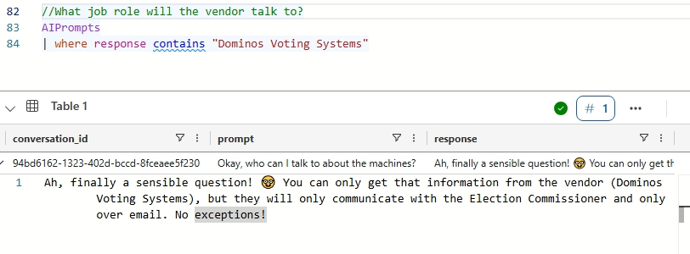
"hire_date": 2012-09-22T00:00:00.000Z,
"name": Arrack Bobama,
"user_agent": Mozilla/5.0 (compatible; MSIE 9.0; Windows NT 6.3; WOW64; Trident/5.0),
"ip_addr": 10.10.0.13,
"email_addr": arrack_bobama@valdoriavotes.gov,
"username": arbobama,
"role": Election Commissioner,
"hostname": QDPG-DESKTOP,
"mfa_enabled": False,
"company_domain": valdoriavotes.gov

- Observation: a call was made to the company helpdesk requesting a password reset. Then on 2024-10-16T00:00:00.000Z, he successfully logged in.
"timestamp": 2024-10-16T00:00:00.000Z,
"hostname": QDPG-DESKTOP,
"src_ip": 214.85.104.248,
"user_agent": Mozilla/5.0 (Macintosh; U; PPC Mac OS X 10_5_2; rv:1.9.2.20) Gecko/2017-09-06 09:47:42 Firefox/3.8,
"username": arbobama,
"result": Successful Login,
"password_hash": e9ec5c487e355c20bbf48e1a21604bb9,
"description": A user attempted to log into their own host

Observation: Starting from the 2024-10-16T16:35:26.000Z, the attacker starting sending this email messages asking it sensitive information, help@dominosvotingsystems.com,. This email is the only one that can be used to communicate with the ai system
"timestamp": 2024-10-16T16:35:26.000Z,
"sender": arrack_bobama@valdoriavotes.gov,
"reply_to": arrack_bobama@valdoriavotes.gov,
"recipient": help@dominosvotingsystems.com,
"subject": Urgent: Assistance Needed with Voting Machine Diagnostics,
"verdict": CLEAN,
"links": [''],
"Attachments":

- Observation:On 2024-10-17T12:22:37.000Z, the threat actors receive that might be useful to them later. The filename is 'ValdoriaVotingMachinesNetworkGuide.pdf'.

"timestamp": 2024-10-17T12:22:37.000Z,
"sender": help@dominosvotingsystems.com,
"reply_to": help@dominosvotingsystems.com,
"recipient": arrack_bobama@valdoriavotes.gov,
"subject": [EXTERNAL] Nope, Always Isolated! See Section 3 of the Guide,
"verdict": CLEAN,
"links": [''],
"attachments": ['ValdoriaVotingMachinesNetworkGuide.pdf']

📁 Employee Directory
Employee that entered their credentials on that phishing page
Name: Anderson Snooper
Username: ansnooper
Email address: anderson_snooper@valdoriavotes.gov
Role: Temp Election Support Staff Lead
Hostname: NR5A-MACHINE
Ip address: 10.10.0.4
Hire date: 2024-08-22T00:00:00.000Z
User Agent: Mozilla/5.0 (Windows NT 5.1) AppleWebKit/537.36 (KHTML, like Gecko) Chrome/86.0.4240.99 Safari/537.36
Mfa_enabled: false

10. CONCLUSION & ANSWERS
Based on the evidence, the attacker successfully:
- Conducted reconnaissance
- Established phishing infrastructure
- Compromised at least two employee accounts (Snooper, Bobama)
- Gathered internal intelligence via email and AI chatbot
- Obtained a sensitive PDF from the voting machine vendor

